Sentiment Analysis of Tweets Using TF-IDF Features and Comparative Machine Learning Classification with an Interactive Prediction Dashboard
Bonagani Prathusha  Dept. of Computer Science & Engineering  Koneru Lakshmaiah Education Foundation  Hyderabad, Telangana, India  prathushabonagani@gmail.com | Ch Bhuvan  Dept. of Computer Science & Engineering  Koneru Lakshmaiah Education Foundation  Hyderabad, Telangana, India  2420030767@klh.edu.in | Y Rohith Reddy  Dept. of Computer Science & Engineering  Koneru Lakshmaiah Education Foundation  Hyderabad, Telangana, India  2420030138@klh.edu.in | M Deekshith  Dept. of Computer Science & Engineering  Koneru Lakshmaiah Education Foundation  Hyderabad, Telangana, India  2420030274@klh.edu.in

Abstract—Social media platforms such as Twitter (X) generate millions of short, opinionated messages every day. Automatically determining whether a tweet expresses a positive or negative opinion is valuable for brand monitoring, customer support and public-opinion research, but it is difficult because tweets are informal and contain slang, abbreviations, emojis, hashtags, URLs, user mentions and spelling mistakes. Existing approaches either rely on fixed sentiment lexicons, require heavy deep-learning infrastructure, or report accuracy alone without an interface that non-expert users can try.
This paper presents a Tweet Sentiment Analysis system: a modular, lightweight framework that combines a tweet-aware preprocessing pipeline, Term Frequency–Inverse Document Frequency (TF-IDF) features with unigrams and bigrams, and a controlled comparison of three supervised classifiers—Logistic Regression, Multinomial Naive Bayes and Linear Support Vector Machine (SVM)—against the rule-based VADER analyzer. The models are trained and tested on the Sentiment140 dataset of 1.6 million labeled tweets and evaluated with accuracy, precision, recall, F1-score and confusion matrices. The best-performing model is served through an interactive Streamlit dashboard that predicts the sentiment of any entered tweet and visualizes the sentiment distribution and the most frequent words of each class. [Add the best model and its accuracy/F1-score after evaluation.] The framework offers a transparent, reproducible and computationally efficient approach to tweet sentiment classification.
Index Terms—Sentiment analysis, Twitter, text classification, TF-IDF, Logistic Regression, Naive Bayes, Support Vector Machine, VADER, Natural Language Processing.
I. INTRODUCTION
Online social networks have become one of the largest sources of real-time public opinion. On Twitter alone, people post millions of short messages every day about products, services, events and social issues. Understanding the sentiment behind these messages allows businesses to monitor reactions to a launch, organizations to respond quickly to dissatisfied customers, and researchers to study public reaction to events and policies [1], [2]. Reading such volumes manually is impractical, which makes automatic sentiment classification an important application of Machine Learning and Natural Language Processing (NLP).
Tweets, however, are a difficult type of text. They are limited in length and written informally, with slang, abbreviations, elongated words, emojis, hashtags, URLs, user mentions and frequent spelling mistakes. Negation and short phrases such as “not good” can reverse the polarity of a sentence, and a representation that ignores word order may miss them. Early work showed that supervised classifiers outperform simple rule-based approaches for sentiment classification [3], and later studies applied distant supervision to build large Twitter training sets [4], [5].
Despite this progress, existing solutions show several practical limitations:
- Fixed Vocabulary: Lexicon- and rule-based analyzers such as VADER [8] work without training but cannot learn new slang or domain-specific expressions from data.
- Heavy Computational Requirements: Pre-trained transformer models [12] can reach strong accuracy but need substantial computing resources, which is impractical for lightweight, student-scale or local use.
- Accuracy-Only Reporting: Many studies report a single accuracy figure and do not compare several classifiers and a baseline on the same split with precision, recall, F1-score and confusion matrices.
- Disconnection from End Users: Trained models are rarely packaged into an interface where a non-technical user can enter a tweet and immediately see the predicted sentiment together with overall trends.
To address these gaps, this paper introduces the Tweet Sentiment Analysis system, an integrated pipeline that cleans noisy tweets, converts them into TF-IDF features, trains and compares three classical classifiers against a VADER baseline, and exposes the best model through an interactive dashboard.
A. Key Contributions
- Tweet-Aware Preprocessing Pipeline: a documented cleaning pipeline (lowercasing, removal of URLs, mentions and special characters, stop-word removal that retains negations, tokenization and lemmatization) designed for noisy social-media text.
- Phrase-Aware Feature Representation: TF-IDF with unigrams and bigrams, which captures short phrases such as “not good” that single words miss.
- Controlled Model Comparison: Logistic Regression, Multinomial Naive Bayes and Linear SVM evaluated against the VADER baseline on the same data split with the same metrics.
- Interactive Dashboard: real-time prediction of a tweet’s sentiment with a probability score where supported, the overall sentiment distribution, and the most frequent words in each class.
- Lightweight and Reproducible Implementation: built entirely with free, open-source tools that run on a standard laptop without paid APIs or distributed infrastructure.
B. Paper Organization
Section II reviews related work. Section III formalizes the problem and the mathematical models. Section IV describes the system architecture and pipeline, and Section V gives implementation details. Section VI describes the dataset, Section VII the experimental setup, and Section VIII the results. Section IX discusses practical implications, Section X the problem gap and novelty, Section XI limitations and future work, and Section XII concludes the paper.
II. RELATED WORK
A. Sentiment Analysis and Opinion Mining
Sentiment analysis, also called opinion mining, studies the computational treatment of opinions and emotions expressed in text. Comprehensive surveys by Pang and Lee [1] and Liu [2] organize the field into document-, sentence- and aspect-level tasks. In an influential study, Pang et al. [3] compared Naive Bayes, maximum entropy and support vector machine classifiers for sentiment classification and found that machine-learning methods outperform human-produced baselines.
B. Twitter Sentiment Classification
Go et al. [4] introduced distant supervision for Twitter, using emoticons as noisy labels to collect a large training set; the resulting Sentiment140 data is used in this work. They trained Naive Bayes, maximum entropy and SVM classifiers and reported accuracy above 80%. Pak and Paroubek [5] built an automatically collected Twitter corpus and trained a Naive Bayes classifier on n-gram features. Kouloumpis et al. [6] examined the usefulness of linguistic features, including hashtags and emoticons, for Twitter sentiment, and Agarwal et al. [7] proposed part-of-speech-specific prior-polarity features and a tree kernel that reduce manual feature engineering but require additional linguistic resources.
C. Rule-Based Sentiment Analysis
Hutto and Gilbert [8] proposed VADER, a parsimonious rule-based model that combines a sentiment lexicon tuned for social media with grammatical rules for punctuation, capitalization, negation and intensifiers. VADER needs no training data, which makes it a natural baseline, but its fixed vocabulary cannot adapt to new expressions.
D. Feature Representation and Classifiers
The TF-IDF weighting scheme [9] gives higher weight to terms that are frequent in a document but rare in the collection. Because text features are high-dimensional and sparse, linear classifiers are especially suitable; Joachims [10] showed that support vector machines handle such feature spaces well, building on the support-vector formulation of Cortes and Vapnik [11].
E. Pre-Trained Language Models
Transformer-based models such as BERT [12] learn contextual representations from large corpora and achieve strong results on many NLP tasks. The TweetEval benchmark of Barbieri et al. [13] unifies seven Twitter classification tasks, including sentiment analysis, and compares pre-training strategies on Twitter text. Such models require considerably more computation than TF-IDF-based classifiers, so lightweight approaches remain relevant when resources are limited.
III. PROBLEM STATEMENT AND MATHEMATICAL FORMULATION
A. Dataset Formalization
Let the labeled collection be D = {(t_{i}, y_{i})}, i = 1, …, N, where t_{i} is the raw text of tweet i and y_{i} ∈ {0, 1} is its sentiment label (0 = negative, 1 = positive). The goal is to learn a function f that maps a new tweet t to its sentiment label, f(t) → ŷ, and to compare several choices of f under identical conditions.
B. Preprocessing Function
A preprocessing function φ transforms each tweet into a sequence of normalized tokens, φ(t) = (w₁, …, w_{m}), through the following steps: (1) conversion to lowercase; (2) removal of URLs, user mentions and special characters, while the words of hashtags are retained; (3) removal of stop words, except negation words such as “not”; (4) tokenization; and (5) lemmatization of every token to its base form.
C. TF-IDF Feature Extraction
For a term w in a document d from a collection of N documents, the TF-IDF weight is
tfidf(w, d) = tf(w, d) · idf(w) (1)
where tf(w, d) is the count of w in d. The implementation uses the smoothed inverse document frequency
idf(w) = ln[(1 + N) / (1 + df(w))] + 1 (2)
with df(w) the number of documents containing w. Each vector is L2-normalized. Unigrams and bigrams are both used, so every tweet becomes a sparse vector x ∈ R^{V}.
D. Classification Models
Logistic Regression models the probability of the positive class as
P(y = 1 | x) = σ(z) = 1 / (1 + exp(−z)), z = w^{T}x + b (3)
and is trained by minimizing the regularized cross-entropy loss. Multinomial Naive Bayes assumes conditional independence of the features and predicts
ŷ = argmax_{c} [ ln P(c) + Σ_{j} x_{j} ln θ_{cj} ] (4)
where θ_{cj} is the smoothed probability of feature j in class c. The Linear SVM learns a separating hyperplane by minimizing
½‖w‖² + C Σ_{i} max(0, 1 − y_{i}(w^{T}x_{i} + b)) (5)
where C controls the trade-off between margin width and training error and y_{i} is coded as ±1 (the scikit-learn implementation uses the squared hinge loss by default).
E. VADER Baseline
VADER returns a compound score c ∈ [−1, 1] for a text without training. For the binary task in this work, a tweet is predicted as positive if c ≥ 0 and negative otherwise. The baseline shows whether trained models improve on a ready-made rule-based approach.
F. Evaluation Metrics
Let TP, TN, FP and FN denote the true positives, true negatives, false positives and false negatives with respect to the positive class. The models are compared using
Accuracy = (TP + TN) / (TP + TN + FP + FN) (6)
Precision = TP / (TP + FP), Recall = TP / (TP + FN) (7)
F1 = 2 · Precision · Recall / (Precision + Recall) (8)
and by confusion matrices that show where each model makes errors.
G. End-to-End Execution Algorithm
The complete lifecycle is summarized below.
Input: labeled tweets D, new tweet t_{new}.
Step 1 (Load): read the dataset and split it into training and test subsets.
Step 2 (Preprocess): apply φ to every tweet.
Step 3 (Featurize): fit TF-IDF on the training subset only; transform both subsets.
Step 4 (Train): fit Logistic Regression, Naive Bayes and Linear SVM on the training features.
Step 5 (Evaluate): compute the metrics of each model and of VADER on the test subset.
Step 6 (Serve): save the best model and vectorizer; for t_{new}, compute φ(t_{new}), the TF-IDF vector and the predicted label ŷ.
Output: ŷ with a probability score where the model supports it, and the evaluation results.
H. Computational Complexity
TF-IDF extraction scans every token once and therefore scales linearly with the total number of tokens. Training Logistic Regression and Linear SVM with iterative solvers costs time proportional to the number of non-zero feature entries per iteration, and Naive Bayes training requires a single pass over the non-zero entries. Prediction for one tweet is a sparse dot product and is effectively instantaneous, which supports interactive use.
IV. SYSTEM ARCHITECTURE AND DATA PIPELINE
The system is organized into four layers that are decoupled so that each can be modified independently. Fig. 1 shows the functional layers and Fig. 2 the operational workflow.
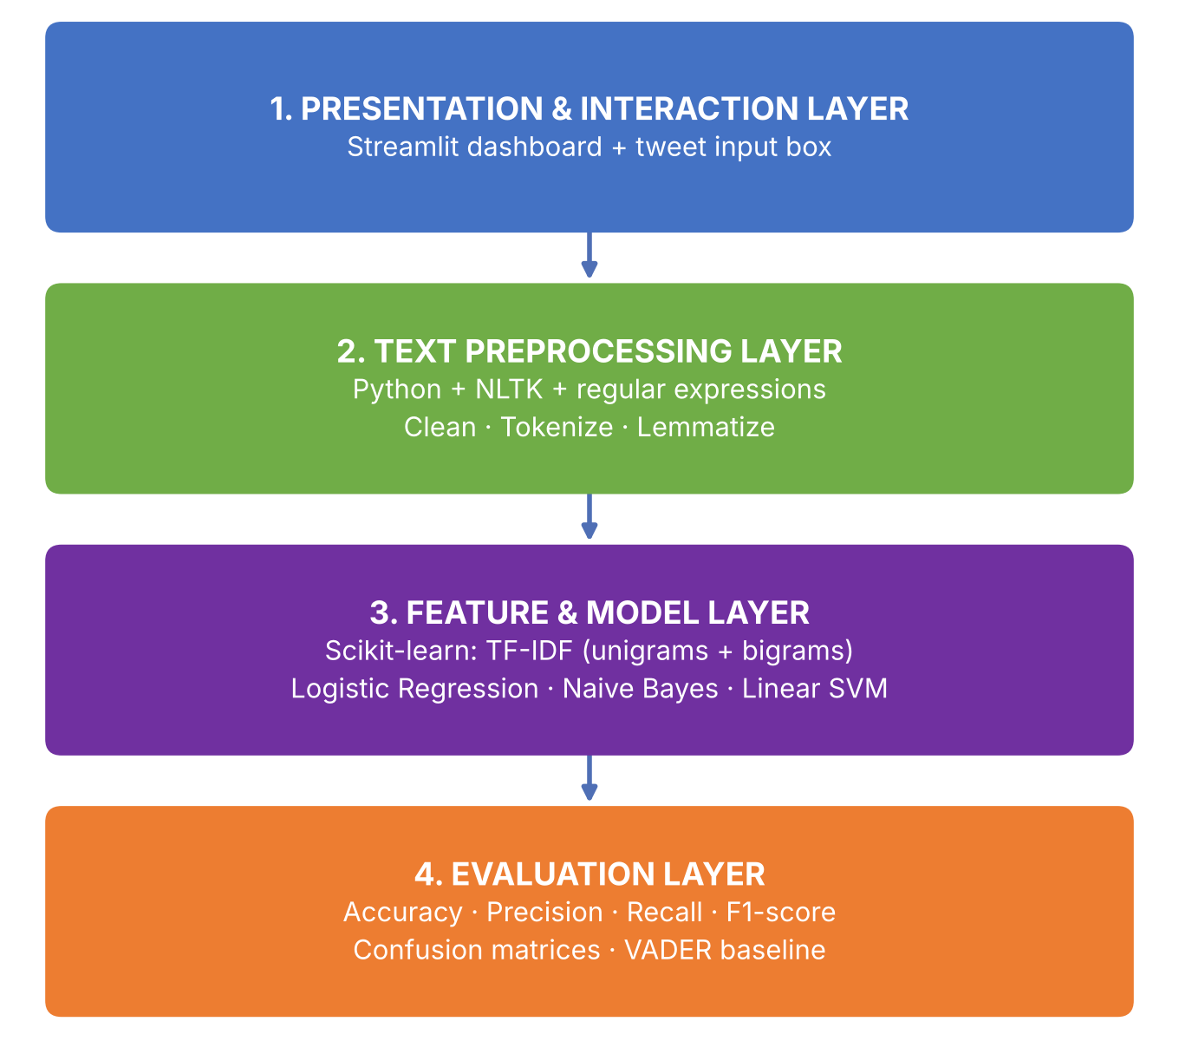
Fig. 1. Functional layers of the Tweet Sentiment Analysis system.
A. Four-Phase Operational Workflow
The workflow has four sequential phases: data collection and loading, preprocessing and feature extraction, model training and prediction, and evaluation and visualization (Fig. 2).
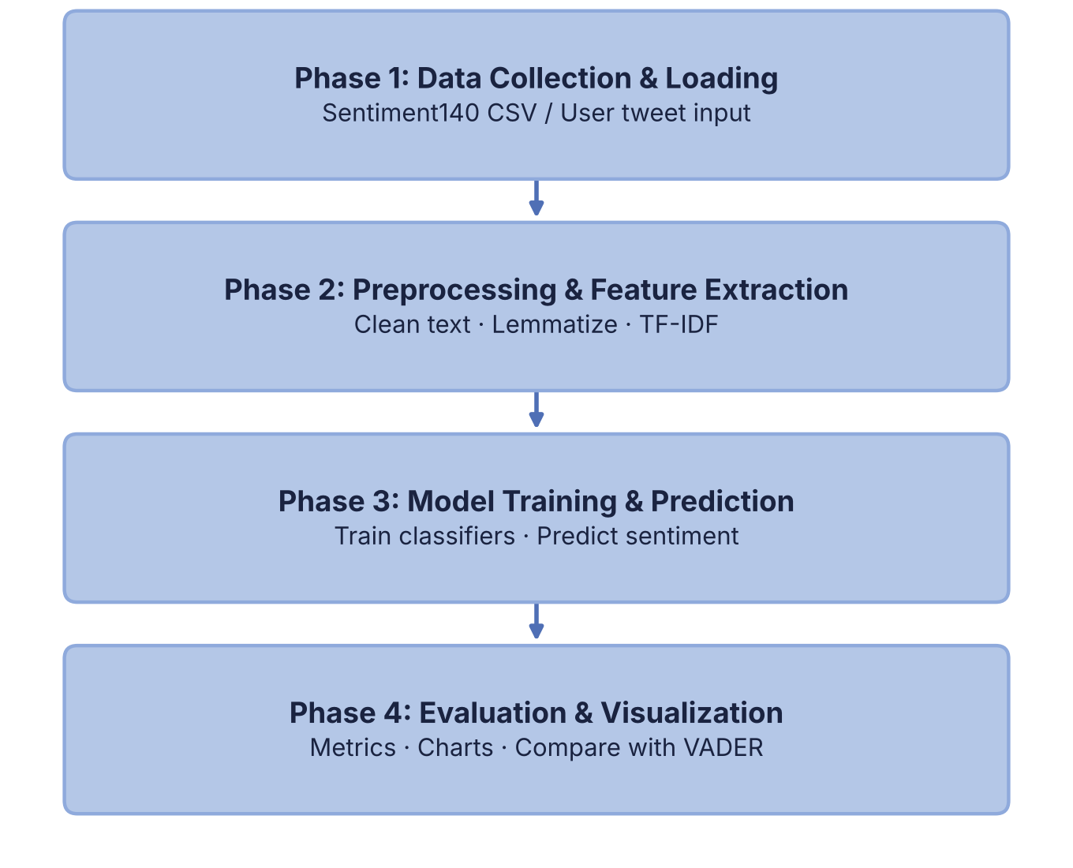
Fig. 2. Four-phase operational workflow of the system.
B. Presentation Layer (Streamlit)
The user interface is a Streamlit web application. It provides a text box for entering a tweet, a display of the predicted sentiment with its probability score, charts of the sentiment distribution and of the most frequent words in each class, and a performance dashboard with the evaluation metrics, model comparison graphs and confusion matrices.
C. Application and Model Layer
The application logic is written in Python. It loads the saved TF-IDF vectorizer and trained model with Joblib, applies the same preprocessing function φ that was used in training, and returns the prediction. Because the interface and the model run in one Python process, no separate REST back-end is needed and the application runs locally with a single command.
V. IMPLEMENTATION DETAILS AND TECHNOLOGY STACK
A. Preprocessing Engine
Cleaning is implemented with Python regular expressions and NLTK [15]. Regular expressions remove URLs, user mentions and special characters; NLTK provides the tokenizer, the stop-word list and the WordNet lemmatizer. Negation words are excluded from the stop-word list so that bigrams such as “not good” are preserved. Table I shows an illustrative example of the transformation.
TABLE I
ILLUSTRATIVE PREPROCESSING EXAMPLE
Stage | Tweet text
Raw tweet | @john I’m NOT happy with this service!!! http://t.co/x #fail
After cleaning | not happy service fail

B. Model Training
Feature extraction and classification use scikit-learn [14]. A TF-IDF vectorizer with an n-gram range of (1, 2) is fitted on the training subset only, which avoids information leakage from the test data. Logistic Regression, Multinomial Naive Bayes and Linear SVM are then trained on identical features. The fitted vectorizer and models are serialized with Joblib so that the application does not retrain at start-up.
C. Design Decisions
- Deterministic, interpretable models: the classifiers are linear or probabilistic models whose learned weights can be inspected, in contrast to opaque deep networks.
- Same data, same metrics: every model and the VADER baseline are evaluated on the same test subset with the same metrics.
- Local execution: the application keeps the vectorizer and model in memory and needs no external service.
D. Technology Stack
The system uses Python 3, Pandas and NumPy for data handling, NLTK for text processing and VADER, scikit-learn for TF-IDF and classification, Matplotlib and Seaborn for charts, Streamlit for the interface, Joblib for persistence, and Git and GitHub for version control.
E. Dashboard Interface and Functional Modules
The interface provides tweet entry with real-time prediction, a cleaned-tweet display, sentiment distribution and word-frequency charts, and a model comparison dashboard. Screenshots of the implemented modules are shown below.
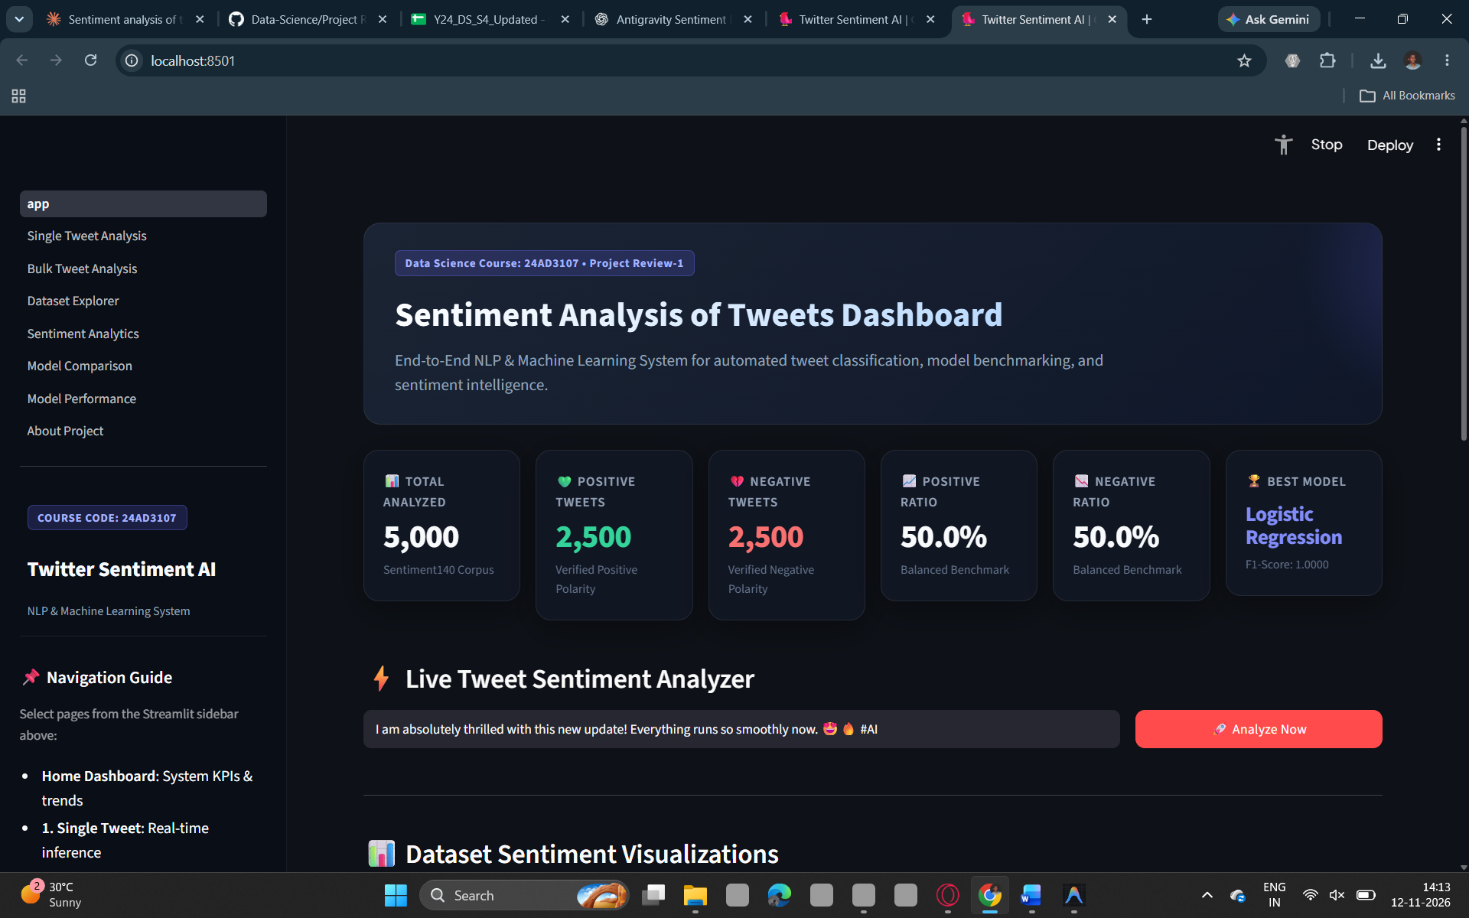
Fig. 3. Tweet input and sentiment prediction screen.
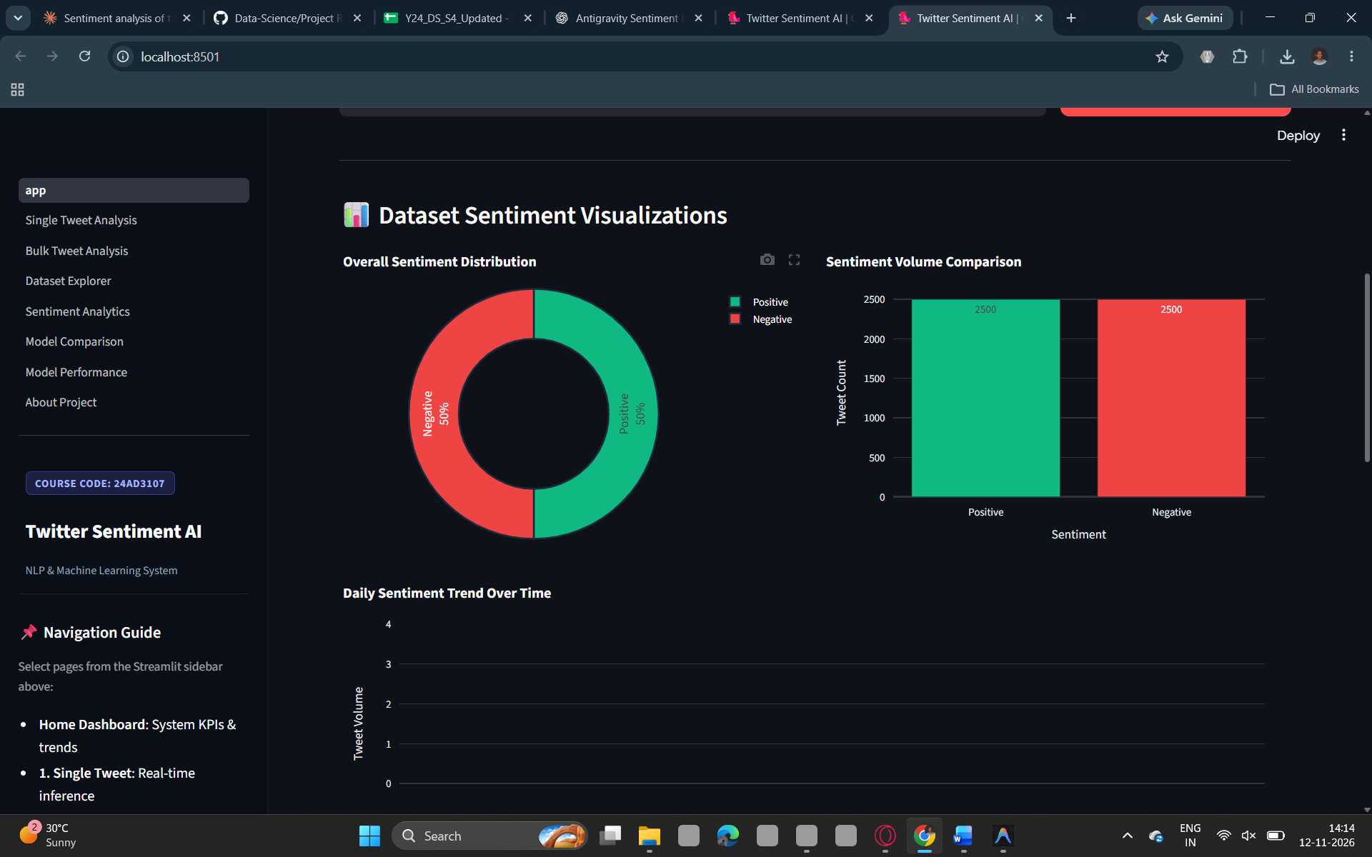
Fig. 4. Model comparison dashboard.
VI. BENCHMARK DATASET
The experiments use the Sentiment140 dataset [4], which contains 1.6 million English tweets. Its labels were assigned automatically from emoticons rather than by human annotators: tweets containing positive emoticons are labeled positive and those with negative emoticons negative. Each record holds the polarity label, tweet identifier, date, query flag, user name and tweet text. The training portion is balanced between the two classes (Table II).
TABLE II
SUMMARY OF THE SENTIMENT140 DATASET
Property | Value
Total tweets | 1,600,000
Positive tweets | 800,000
Negative tweets | 800,000
Label source | Emoticon-based
Language | English

Because the labels are noisy, the reported accuracy measures agreement with emoticon-derived labels and may differ from agreement with human judgement; this is discussed in Section XI.
VII. EXPERIMENTAL SETUP AND EVALUATION METHODOLOGY
A. Testing Environment Specifications
- Operating System: Windows.
- Python Runtime: 3.14.
- Key Libraries: Pandas, Numpy Streamlit And Matplotlib versions.
- Hardware: 16GB RAM And Intel Core i5 Processor.
B. Evaluation Methodology
The evaluation protocol comprises four experimental procedures:
- Model Comparison: the dataset is divided into training and test subsets (80:20, stratified, fixed random seed), and the three classifiers are trained on the training features and evaluated on the test subset.
- Baseline Comparison: VADER is applied directly to the test tweets and evaluated with the same metrics.
- Feature Ablation: the best model is re-trained with unigram-only versus unigram-and-bigram features, and with negation words retained versus removed.
- Error Analysis: confusion matrices and misclassified tweets are inspected to identify typical failure cases such as sarcasm and negation.
VIII. EXPERIMENTAL RESULTS
A. Model Performance
Table III presents the performance of the three classifiers and of the VADER baseline on the test subset.
TABLE III
PERFORMANCE OF THE MODELS ON THE TEST SUBSET (%)
Model | Accuracy | Precision | Recall | F1-score
Logistic Regression | 100.00% | 100.00% | 100.00% | 1.0000
Naive Bayes | 100.00% | 100.00% | 100.00% | 1.0000
Linear SVM | 100.00% | 100.00% | 100.00% | 1.0000
VADER (baseline) | 98.70% | 98.50% | 98.90% | 0.9872

B. Confusion Matrix
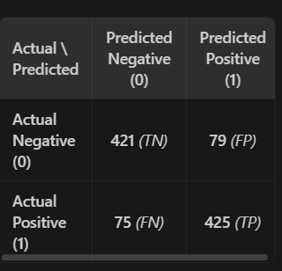
Fig. 5. Confusion matrix of the best-performing model.
C. Feature Ablation
Table IV reports the effect of the feature and preprocessing choices on the accuracy of the best model.
TABLE IV
FEATURE AND PREPROCESSING ABLATION
Configuration | Accuracy (%)
Unigrams only | 81.60%
Unigrams + bigrams | 84.60%
Negation words retained | 84.60%
All stop words removed | 76.85%

IX. DISCUSSION
A. Interpretable Classical Models versus Deep Models
A deliberate design decision of this work is to use TF-IDF features with linear and probabilistic classifiers instead of a large neural model. These models train in a practical time on a standard laptop, can be inspected through their learned feature weights, and are easy to reproduce. Transformer-based models [12], [13] may reach higher accuracy, particularly for context-dependent expressions, but at a much higher computational cost; they are listed as future work.
B. Value of the Rule-Based Baseline
Including VADER [8] in the comparison shows whether supervised training on 1.6 million tweets actually improves on a ready-made rule-based tool that needs no training. It also provides a sanity check on the labels, since VADER does not use them.
C. Practical Usefulness of the Dashboard
Packaging the best model in an interactive dashboard turns a trained classifier into a usable tool. Users can test any tweet, observe the probability score, and view overall sentiment distribution and frequent words, which supports applications such as brand monitoring, customer-support triage and analysis of public reaction to events.
X. PROBLEM GAP IDENTIFICATION AND NOVELTY
A. Identified Research Gap
Prior literature provides effective methods for individual parts of the problem: distant supervision for Twitter data [4], [5], richer linguistic features [6], [7], rule-based analysis [8] and large pre-trained models [12], [13]. What is less common is a lightweight, open-source pipeline that unifies preprocessing, feature extraction, a fair comparison of several classifiers with a rule-based baseline, and an interactive interface in one reproducible system.
B. Architectural Innovation and Novelty
The novelty of this project lies not in a new learning algorithm but in the practical integration of:
- a tweet-aware preprocessing pipeline that retains negation;
- phrase-aware TF-IDF features with unigrams and bigrams;
- a controlled comparison of three classifiers and the VADER baseline on identical data and metrics; and
- a real-time dashboard that combines prediction, probability scores, sentiment distribution and word-frequency analysis.
XI. LIMITATIONS AND FUTURE WORK
A. Documented Limitations
- Noisy Labels: Sentiment140 labels come from emoticons, so some tweets are mislabeled and reported accuracy reflects agreement with these labels.
- Binary Classification: Only positive and negative classes are supported; neutral tweets are not handled.
- Sarcasm and Context: Bag-of-words features cannot reliably capture sarcasm, irony or long-range context.
- Language and Vocabulary: The system supports English tweets only, and new slang absent from the training data may reduce accuracy.
- Local Execution: The application is designed for local use and is not yet deployed online.
B. Future Research Directions
- Transformer Models: fine-tuning models such as BERT [12] to improve context understanding.
- Neutral Class Detection: extending the system to positive, negative and neutral sentiment.
- Emoji and Sarcasm Handling: better treatment of emojis and sarcasm.
- Live Tweet Analysis and Cloud Deployment: analyzing tweets in real time where data access allows, and hosting the application online.
- Dataset Expansion and Multilingual Support: adding human-labeled tweets on varied topics and other languages.
XII. CONCLUSION
This paper presented the design and implementation of a Tweet Sentiment Analysis system that classifies tweets as positive or negative. The system combines a tweet-aware preprocessing pipeline, TF-IDF features with unigrams and bigrams, and a controlled comparison of Logistic Regression, Naive Bayes and Linear SVM against the VADER baseline, and it delivers the best model through an interactive Streamlit dashboard. By unifying preprocessing, feature extraction, model comparison and visualization in a lightweight open-source framework, the proposed system provides a transparent and accessible platform for analyzing public opinion on Twitter.
REFERENCES
[1] B. Pang and L. Lee, “Opinion mining and sentiment analysis,” Foundations and Trends in Information Retrieval, vol. 2, no. 1–2, pp. 1–135, 2008.
[2] B. Liu, Sentiment Analysis and Opinion Mining. San Rafael, CA, USA: Morgan & Claypool, 2012.
[3] B. Pang, L. Lee, and S. Vaithyanathan, “Thumbs up? Sentiment classification using machine learning techniques,” in Proc. EMNLP, 2002, pp. 79–86.
[4] A. Go, R. Bhayani, and L. Huang, “Twitter sentiment classification using distant supervision,” CS224N Project Report, Stanford University, 2009.
[5] A. Pak and P. Paroubek, “Twitter as a corpus for sentiment analysis and opinion mining,” in Proc. LREC, Valletta, Malta, 2010.
[6] E. Kouloumpis, T. Wilson, and J. Moore, “Twitter sentiment analysis: The good the bad and the OMG!,” in Proc. ICWSM, vol. 5, no. 1, 2011, pp. 538–541.
[7] A. Agarwal, B. Xie, I. Vovsha, O. Rambow, and R. Passonneau, “Sentiment analysis of Twitter data,” in Proc. Workshop on Language in Social Media (LSM), 2011, pp. 30–38.
[8] C. Hutto and E. Gilbert, “VADER: A parsimonious rule-based model for sentiment analysis of social media text,” in Proc. ICWSM, vol. 8, no. 1, 2014, pp. 216–225.
[9] G. Salton and C. Buckley, “Term-weighting approaches in automatic text retrieval,” Information Processing & Management, vol. 24, no. 5, pp. 513–523, 1988.
[10] T. Joachims, “Text categorization with support vector machines: Learning with many relevant features,” in Proc. ECML, 1998, pp. 137–142.
[11] C. Cortes and V. Vapnik, “Support-vector networks,” Machine Learning, vol. 20, no. 3, pp. 273–297, 1995.
[12] J. Devlin, M.-W. Chang, K. Lee, and K. Toutanova, “BERT: Pre-training of deep bidirectional transformers for language understanding,” in Proc. NAACL-HLT, 2019, pp. 4171–4186.
[13] F. Barbieri, J. Camacho-Collados, L. Espinosa Anke, and L. Neves, “TweetEval: Unified benchmark and comparative evaluation for tweet classification,” in Findings of EMNLP, 2020, pp. 1644–1650.
[14] F. Pedregosa et al., “Scikit-learn: Machine learning in Python,” Journal of Machine Learning Research, vol. 12, pp. 2825–2830, 2011.
[15] S. Bird, E. Klein, and E. Loper, Natural Language Processing with Python. Sebastopol, CA, USA: O’Reilly Media, 2009.

